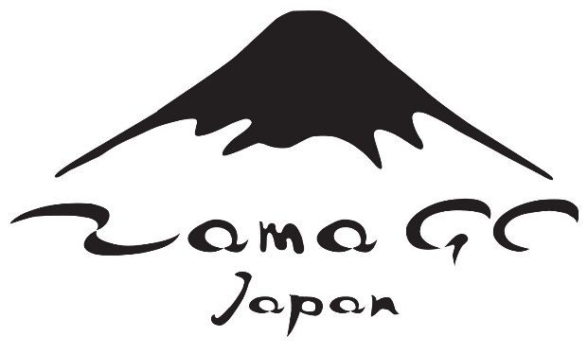

Camp Zama Golf Course Honorary Golf Member Program

A limited number of Honorary Golf Course Memberships will be available annually.

To be eligible you must agree to be a frequent user of the Golf Course and to be a regular sponsor of guests for golf.

We expect each Honorary Member to play a minimum of 25 rounds per year.

If you are granted an Honorary Golf Membership you will receive unescorted access to Camp Zama for the purpose of playing golf.

You will be able to sponsor 7 guests and two additional vehicles.

OPTIONS AVAILABLE

10 Play Card $600 (good for one year)

Weekday Unlimited $3000

7 Days Unlimited $5000

